Patients matter July 2014
Welcome to the latest edition of Cannington Health Centre’s patient newsletter
Need a copy in bigger print? Ask at reception

Stay safe in the sun
For a change, we’ve had some really hot weather already this summer so remember to take suitable precautions:
Stay in the shade between 11 & 3
Cover up with clothing and a hat
Use high factor sun lotion and reapply frequently
Drink plenty (but not too much alcohol)
Sunburn is harmful at any age but particularly so for children so take extra care.

The very young and the very old are particularly vulnerable, so
Don’t overdress, wear loose, cool clothing
Find the coolest room and go there
Light coloured curtains or metallic blinds will help reflect the heat
Have a cool bath or shower or splash yourself with cool water

If someone feels unwell because of the heat, get them somewhere cool and give them plenty to drink.
Seek medical help if symptoms such as breathlessness, chest pain, confusion, dizziness won’t go away or get worse

Reducing unplanned admissions
No-one wants to have a medical emergency which results in being admitted to hospital. We’d all rather remain as well as possible, at home, for as long as possible. What’s more, emergency admissions are very expensive for the NHS and can put a huge strain on hospital resources. For these reasons, the NHS is looking at ways to reduce unplanned/emergency hospital admissions. GPs have been asked to identify which of their patients might be most at risk of an emergency hospital admission and to start the process of personal care planning with those people. We are starting to write to our patients who could be at a higher than average risk of admission. Don’t be alarmed if you receive one of our person care plan letters. You could make a care planning discussion appointment with your GP or tell us that you would rather not be part of this scheme. It is entirely your choice.
The NHS also now requires all patients aged 75 and above to have a ‘named GP’. We wrote last month to all our older patients to inform them of their named GP. For most patients their named GP will be the doctor they registered with or usually see and won’t have come as any surprise. If we had been able to recruit a successor for Dr Ogle then his patients would simply have transferred to the new doctor. As we have been unable to recruit, we have shared out his patients amongst the other GPs. If you would prefer to be assigned to a different GP, just let us know and providing the relative numbers of patients for each of our GPs remains roughly in balance, we will make the change.

GP availability
As mentioned above, we have been unable to recruit a successor to Dr Ogle who retired at the end of April this year. Added to this Dr Searle was on sick leave for 8 weeks. Furthermore, locum doctors are getting harder to obtain. All these factors have combined to make a difficult few months for us all. There have been longer wait times for routine appointments although we continue to see on the same day everyone who says they need to be seen that day. Thankfully Dr Searle has returned and from August 2014 she will be doing an extra session a week, and becomes a partner. Dr Bray is also working an extra session a week and our nurse practitioner, Denise Sharratt, will be working an extra two sessions a week from September. We should start to see the benefits of these changes from September but we still have to get through the summer holiday period when our own GPs will be taking leave with their families and locums will be even harder to obtain.

What can patients do to help the situation?
Firstly, think ahead. Don’t leave it until the last minute to book your appointment for that essential blood test or whatever.
Secondly, if you can’t keep an appointment, let us know giving us as much notice as possible. In the last 3 months, 245 patients didn’t turn up for appointments and the equivalent of 726 ten minute appointments were lost. The last 3 months have been particularly bad because of the road works on the outskirts of Cannington which delayed many people unexpectedly. We don’t really have any sanctions we can enforce on non-attenders but you know who you are, please don’t abuse the service.
Thirdly, be willing to see any GP or the nurse if we can’t offer you an appointment with your usual GP in a timeframe to suit you.
Finally, sign the RCGP petition to lobby government to ‘put patients first’. See below for details

Put patients first:Back general practice
The problems we’ve experienced are not unique to us. Nationally GPs are worried about the increased pressure and how this is affecting patient care. The National Association for Patient Participation (NAPP) and the Royal College of General Practitioners (RCGP) have launched a campaign called ‘Put patients first: Back General Practice’. This aims to raise public awareness of the difficulties facing general practice including:
- Increasing workload as more people are living longer with long term diseases such as heart disease and diabetes and being looked after by their GP surgery
- Funding has been recycled so that GPs have to do more work just to keep up
- General practice provides over 90% of patient contacts within the NHS but receives just 8.39% of the budget and this is likely to fall to 7.29%
- Fewer doctors are choosing to train as GPs because of the pressures and workload. This is at a time when a high proportion of GPs are approaching retirement age
The campaign is not about protecting GP personal income but about protecting patients.
The organisers are hoping to obtain a million signatures on a petition to government. Please sign up. There is a paper copy of the petition at the health centre or you can go to
www.rcgp.org.uk/campaign-home.aspx

At the same time the British Medical Association is running a parallel campaign, ‘Your GP cares’
Go to www.bma.org.uk/yourgpcares for more information
Please support us in whatever way you can!

Healthwatch
Healthwatch is the organisation set up to help you and your family get the best out of your local health and social care services. It is independent from all the health and social care providers. Healthwatch wants to involve people in shaping services in particular by providing their ‘stories’. These can be good or bad experiences of one or more aspects of health and social care. Go to their website for more information
http://www.healthwatchsomerset.co.uk/
or you can call them on 01823 751403

Quick bits
New Bridgwater Hospital is now open but some of you may have old letters for a future outpatient appointment that give the address of the old hospital at Salmon Parade. This is now closed. Your appointment will be at the new hospital in Bower Lane
Hearing aid batteries can now be collected from the Health Centre. You don’t need to be our patient but you do need to bring your record book.
On-line patient group – support the practice by signing up. Over 200 patients already have. Fill out a form from the practice or go to our website and click on the Patient Group tab
www.cannington.gpsurgery.net
Advance notice of computer system upgrade on 1 October. There will be some disruption but it will also allow us to introduce a better on-line repeat prescription ordering system plus some on-line appointment booking and other improvements. More nearer the time.
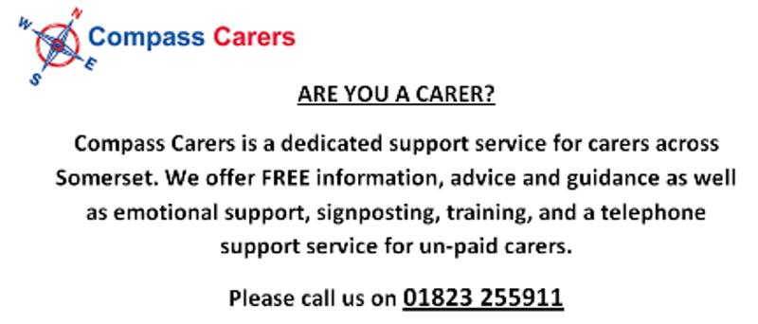
There’s a carer’s support group that meets each month at Bridgwater library. Contact Compass Carers for more information.
Stop press
We will be introducing the Friends and Family Test before 1 September 2014. This is a single question feedback test already common in hospitals now being adopted by GP surgeries. We will be asking you the following:
‘We would like you to think about your recent experiences of our service.
How likely are you to recommend our GP practice to friends and family if they needed similar care or treatment?’
Your feedback is completely anonymous and will help the practice to improve upon its shortcomings and celebrate our good points. Please fill out a response card when you see them!

