Otterhampton Parish
Local Information Sheet as at May 2019

Welcome to our lovely parish, incorporating the main village of Combwich and the two smaller villages of Otterhampton and Steart.

The Parish Council has compiled and publishes this information which we hope you will find useful. We also have Community and Emergency Plans.

FACILITIES

Post Office and Village Store (including off licence)
22 Brookside Rd, Combwich. Tel: 01278 652277
Mon - Fri 9am–7pm; Sat 9am–6pm (closed 1pm-2pm). Closed Sunday.
Post Office: Mon – Fri 9am–5.30am, Saturday 9am – 1pm.

There are 3 post boxes in the parish; at the Post Office, at the bottom of Otterhampton Hill (Crossway Cottages) and at Steart (wall of Ferricies Farm).

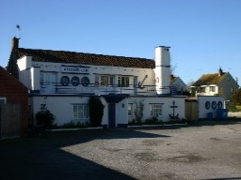
Public House – The Anchor Inn
Riverside, Combwich. Tel: 01278 653612
Open from: 17.00 Monday – Thursday and from 12 noon Fri – Sun
Home cooked food and accommodation.

Village Hall and Harbour View Social Club
Riverside, Combwich. Tel 01278 653531 (Sue and Bruce Barton)

The Club is open Fridays and Saturdays 7pm-midnight; Sundays 2pm-6pm and Monday evenings during the winter skittles season, 7pm-midnight. Annual membership is £2.50 (£1 on each occasion for visitors).

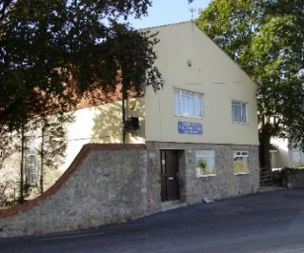
The Hall is used for ad hoc parties, social events and entertainment (booking secretary – Di Davie 01278 652141) and also more regular events as below:

Aerobics, Pilates and Gentle Movement to Music (Tuesdays)
Coffee Morning (every Friday 10am – 12noon)
Village Market (2nd Saturday of month)
Brownies (Monday evening)
Combwich Crafters (Wednesday morning)
Combwich Choir (Thursday evenings, 2nd and 4th Thursday of month)
Art Club (Monday afternoons)
Short Mat Bowls (Monday and Wednesday evenings)
Skittles and Darts
Harbour View Players (including the Pantomime)
Police Surgery (2nd Friday of month)

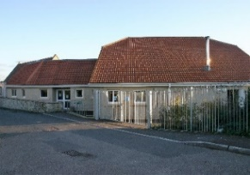
Otterhampton Primary and Pre-School
School Lane, Combwich. School Head: Claire Luce. Tel 01278 652487

Mobile Library
The mobile library visits Combwich every four weeks on a Thursday morning and calls at the School, Harbour and the Post Office (see Otter Tales for specific dates and timings).

Places of Worship
St Peters Church (Church Hill, Combwich)
All Saints Church (closed) and Cemetery (Otterhampton)
St Andrews Church (Steart)
Reverend Alison Waters. Tel 01278 652953

HEALTH AND WELFARE

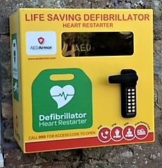
Defibrillators
There are 2 defibrillators, one in the centre of Combwich on the grassed area at the junction of Brookside Rd/Wharf Rd and one at Steart on the wall of the old Chapel adjacent to Channel View.

GP Surgeries within this catchment area
Cannington Health Centre, Mill Lane, Cannington. Tel 01278 652335 (this surgery also provides a prescription service delivered to Combwich Post Office on a Wednesday afternoon).
Quantock Medical Centre, Banneson Rd, Nether Stowey. Tel: 01278 732696

Hospitals
Musgrove Park Hospital, Parkfield Drive, Taunton TA1 5DA. Major injuries and Emergencies 24 hours. Tel: 01823 333444

Bridgwater Community Hospital, Bower Lane, Bridgwater TA6 4GU
Minor injuries unit (not 24 hour). Open from 0700 to 2230 hrs, 7 days per week. Tel: 01278 436555

Recycling and Refuse Collections
Bins are collected on Friday mornings (household and garden waste alternate weeks). Recycling material and food waste are collected weekly. One day later following Bank Holidays.

Recycling Centres
Saltlands Avenue, Chilton St, Bridgwater TA6 3JS. Tel: 01278 444877.
Roughmoor Industrial Estate, Williton TA4 4RF. Tel: 01984 632221.

Dog and Litter Bins
Bins are situated at Brookside Rd garages; the entrance to Wharf Rd (on grassed area near the defibrillator); Wharf Rd (at the entrance to Combwich labs) on the Common opposite Riverview, in and around the play area, and near the OPRA pavilion adjacent to the track.

TRANSPORT

Public Transport
There are no public transport services provided by Somerset County Council.

Complimentary Bus Service
EDF Energy (Hinkley Point C Power Station) provides a limited complimentary bus service Monday – Friday. Combwich to Bridgwater and Minehead. Timetable available from the Parish Clerk.

Mendip Community Transport provides the subsidised (if eligible) ‘Slinky Bus’ Service from Combwich (pick-up circa 10am) to Bridgwater (return circa 2pm) on a Tuesday. Tel 01749 880948 to book.
Otter Wheels
This is a voluntary door to door car scheme service for parishioners. It is run by volunteers including volunteer drivers from within the parish. This scheme is part subsidised by SCC. Booking Tel 07925 154216 (48 hour notice please).

COMMUNICATION

Communication and Information
The parish has its own website; Combwich.org.uk (owned and managed by OPRA).

Otter Tales
Bi-monthly parish magazine - January, March, May, July, September and November. Delivered to each household in the parish.

Notice boards
There are three noticeboards – by the Play Area, opposite the Post Office and at Steart (the wall of Ferricies Farm).

OTHER ORGANISATIONS

Parish Council
Otterhampton Parish Council meets on the first Thursday of each month (except August). Meetings commence at 7pm and are held at The Village Hall.
Tea, coffee and biscuits are available. Members of the community are very welcome to attend and participate in the meetings.
Chair: XXXXXXXXXXXXXX
Clerk: Aly Prowse Tel 01278 652426; otterhamptonpcclerk@gmail.com
Sedgemoor District Council
We are serviced by Sedgemoor District Council.
Bridgwater House, King Square, Bridgwater TA5 3AR.
Tel: 0300 303 7805. Website: www.sedgemoor.gov.uk
Somerset County Council
County Hall, Taunton, Somerset TA1 4DY
Tel: 0300 123 2224 email generalenquiries@somerset.gov.uk

Otterhampton Parish Recreation Association (OPRA)
This is a registered charity run by volunteers to raise money to provide free events including an annual firework display and lantern parade, an Easter Egg hunt and the senior citizens Christmas meal. Also organises monthly walks.
Chairman: Tina Gardener 01278 652642
Secretary: Ann Leathwood 01278 652399 (contact for 100 Club)
Women’s Institute
The WI meets at Stockland Club on the third Thursday of every month. Dates and details for meetings are printed in Otter Tales.
The President is xxxxxxxxxxxxxxx

OUTDOOR ACTIVITIES

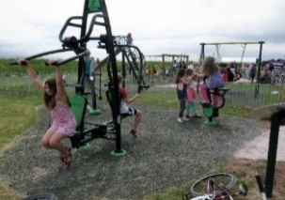
Play and Recreation Area
Combwich Common, Riverside.
This includes the children’s play area, outdoor gym equipment, a recreation shelter, picnic tables and benches.
On the larger common there is also a basketball hoop and a football net.

WWT Steart Marshes
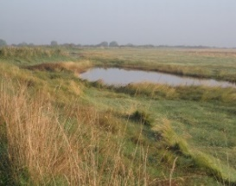
500 – hectare area of wetland habitat on the peninsula (including a multi-purpose footpath and cycle path, plus bridleways). Direct access can be gained from all three villages in the parish.

Bridgwater Bay National Nature Reserve (Natural England)
This is located on the Steart Peninsula.

Combwich Ponds (natural fishery)
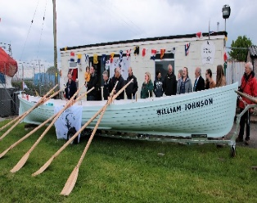
This is run and owned by the Bridgwater Angling Association.
Tel: 01278 457022

Combwich Motor Boat and Sailing Club, plus Gig Rowing Section
Please contact Trevor Reason (Secretary) for details. Tel: 01278 320242 or 07918 703422; trevorreason@yahoo.co.uk. http://www.combwichboatclub.co.uk

Nearest Swimming Pools and Gym Facilities
Quantock Lodge Leisure, Over Stowey TA5 1HD
Tel: 01278 733750. Email: infoquantocklodge.co.uk

1610 Trinity Sports and Leisure
Chilton Street, Bridgwater, TA6 3JA
Tel: 01278 429119. Email: chilton@1610.org.uk

The Mill Health and Fitness Suite (Includes gym and indoor pool)
Mill Farm Caravan and Camping Park, Fiddington, TA51JQ
Tel: 01278 238170. Website: themillfitnesssuite.co.uk

