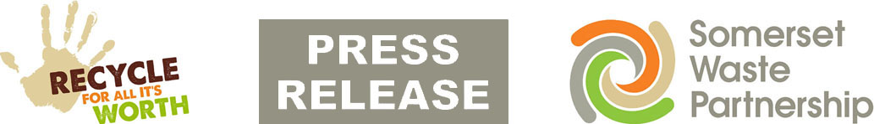

29 May 2020

Recycling centres: Back to summer opening next week

Somerset Waste Partnership’s recycling centres will revert to their usual summer opening hours from Monday 1 June.

As well as the current temporary hours, the odds and even number plate access system will also come to an end from Monday. All other restrictions remain in place as SWP continues the move towards business as usual following Coronavirus closures.

Eleven of the 16 sites reopened on 11 May, and the remaining five on Tuesday (26 May), though materials and access remain restricted.

Please see https://www.somersetwaste.gov.uk/recycling/centres/ from Monday morning for all sites' opening hours – note that for Taunton, Yeovil and Frome it means a return to seven days a week opening.

SWP is continuing its plea for people to only come if it is really necessary and to take full advantage of the weekly kerbside recycling collections, which have continued throughout the crisis.

Long queues are expected at the sites, especially first thing in the morning, as the number of unloading bays has been reduced to allow social distancing. Queue cams are viewable for Bridgwater, Chard, Highbridge, Minehead, Somerton, Street, Taunton and Yeovil. Please check before you leave.

Odd and even number plate access continue until Sunday 31 May:
- Odd numbers on Saturday (for example 01, 19 etc)
- Even numbers on Sunday (for example 02, 18 etc)

A maximum of two people per household will be permitted, gloves must be worn while outside your vehicle and strict social distancing maintained. Trailers and 3.5 tonne vans are only allowed access between 4pm and 6pm on weekdays.

Only materials accepted (and what happens to them):
- Rubbish – material you would usually put in your black rubbish bin, excess black bags not taken by kerbside collections, and bulky items like furniture (landfilled in Somerset, soon to be sent to an Avonmouth energy-from-waste plant)
- Green waste – garden waste such as grass cuttings, leaves, hedge trimmings (composted in Somerset)
- Large household electrical items – white goods, cookers TVs etc (recycled in UK)
- Household hazardous waste, such as solvents, garden chemicals, paint thinners and antifreeze (treated and disposed of in UK)
- Waste cooking oil and engine old, in disposable containers of up to five litres (recycled in UK)
- Scrap metal (recycled in UK)

Any items you would usually pay to have disposed of will not be accepted – including tyres, gas bottles, soil and hardcore, vehicle parts, commercial waste, plasterboard and asbestos.

Access to the normal recycling banks is not possible. So, unless you really need to, please do not bring cardboard, food and drink cans, paper, food waste, plastic bottles, glass bottles and jars. These can be recycled using the continuing weekly recycle collections: https://www.somersetwaste.gov.uk/recycling-collections/

If you want to recycle waste wood, plastic pots tubs and trays, TetraPaks and small electricals, please hold on to them until the sites return to normal.

Mickey Green, SWP Managing Director, said: “This is another step towards business as usual. The restrictions are there to keep everyone safe, but they do reduce capacity so please do only come if you really need to. It’s not business as usual and there’s every chance you will have a lengthy wait.”

For more information about how to reduce and reuse your waste, visit www.somersetwaste.gov.uk
For the latest information about services and any disruption visit www.somersetwaste.gov.uk/coronavirus and follow @somersetwaste on Twitter and Facebook.

[END]

