OTTERHAMPTON PARISH RECREATION ASSOCIATION

Minutes of the OPRA Committee Meeting held on Monday 19th October 2020 at 7pm

By Zoom

PRESENT DRAFT

Tina Gardener (Chair)

Barry Leathwood (Vice Chair)

Ann Leathwood (Secretary)

Sue Frances (Treasurer)

Di Davey

20/13 APOLOGIES Melvyn Fooks, Mary Cornish, Bev Lang, Jacqui Sparks, and Felicity Ashworth.

20/14 MINUTES OF THE LAST MEETING

The minutes of 4th February 2020 were approved by the meeting and will be signed by the chair

20/15 CORRESPONDENCE

None

20/16 TREASURERES REPORT

Cash in Hand £177.03
Bank £767.21
Savings £1482.86
100 Club £2588.55

Total £5015.65

Cheque list to date.
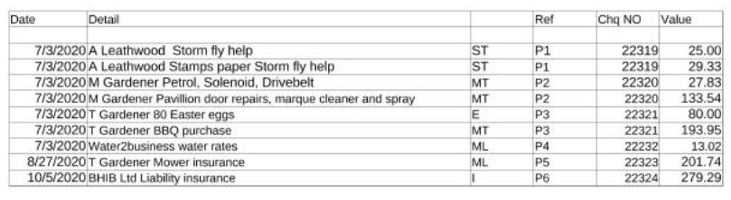
Agreed to transfer £1,000. from 100 Club to the bank account to meet expected expenditure

20/17 CHRISTMAS DINNER

Because of the uncertainty due to the Covid restrictions, it was agreed to consult with those we normally invite to the Christmas dinner on whether to arrange lunch time Christmas lunches in relays during the first week in December, or to postpone the event until circumstances change. Barry agreed to draft a letter for the committee to approve by email. Agreed that the letter be distributed this week with the tear off slip to be returned to the post office by 30th October.

20/18 CHRISTMAS TREE AND LIGHTS

Tina agreed to order the trees for Combwich and Steart. The Combwich tree lighting to take place on Sunday 6th December at 5pm. Tina will check with Mike to ask whether we need more lights for the tree.

Tina will also contact the Rev Alison Waters to establish whether there will be a Christingle service. It was agreed to consider a small gift for children attending.

20/19 OPRA PRINTER

Barry reported the printer will no longer operate and recommended a replacement. A note had previously been circulated to committee members with a recommendation that we purchase an Epson Eco Tank ET- 3750 for £329. This is a Which best buy. It was agreed to make the purchase.

20/20 ANY OTHER RELEVANT BUSINESS

It was reported that the Easter eggs purchased for the annual Easter Egg hunt were donated to the school because the lockdown did not allow the event to take place.

Tina reported that because of the current pandemic it had not been possible to progress the planning application for the replacement Pavilion.

DATE AND TIME OF NEXT MEETING

To be by zoom at a date to be agreed and will deal with the Christmas arrangements.

Signed…………………………………… Date………………………..

