OTTERHAMPTON PARISH RECREATION ASSOCIATION

Minutes of the OPRA Committee Meeting held on 4th February 2020 at 7.30pm

32 Nursery Close

PRESENT

Tina Gardener (Chair) Mary Cornish

Barry Leathwood (Vice Chair) Melvyn Fooks

Ann Leathwood (Secretary) Bev Lang

Sue Frances (Treasurer) Felicity Ashworth

20/01 APOLOGIES Di Davie

20/02 MINUTES OF THE LAST MEETING

The minutes of 21st November 2019 were approved by the meeting and signed by the chair.

20/03 MATTERS ARISING

Village Hall Refurbishment. Tina presented a draft letter to be sent to the village hall committee which was approved with a small amendment. Tina to submit.

20/04 CORRESPONDENCE

None

20/05 TREASURERES REPORT

Cash in Hand £177.03
Bank £214.91
Savings £1777.73
100Club £1825.55

Total £3995.22

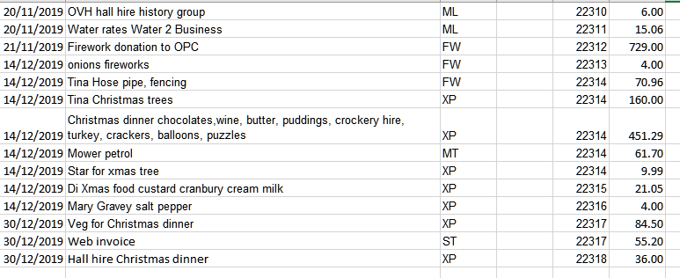
20/06 CHRISTMAS DINNER AND TREE LIGHTING

Agreed the evening was successful and after a few drop-outs 66 guests were served. The cost per head was £6.36. Reviewing the evening it was agreed that more attention needs to be given to portion control, as although seconds were offered, quite a lot of food particularly turkey was left at the end. Bigger portions next time. A few people complained that the evening went on a bit too long. Agreed that next year we design a timetable for the various activities throughout the evening. Also agreed try to find an alternative supplier of vegetables for next year because of the difficulties experienced this year.

Members commented on the excellent tree that we were able to purchase this year; all be it at extra cost. Thanks to Mike Gardener and his team for erecting the tree and lights.

220/07 PAVILION REPLACEMENT

Agreed to see Ron Page to secure a formal agreement on the transfer of the land required, either by ownership or long-term lease. Tina will make an online planning application at the appropriate time. She has contacted a solicitor to secure an estimate of the cost. It was agreed to seek alternative estimates before making a decision.

It was agreed that a demonstration of our preferred mower replacement be organised as soon as the conditions allow.

Agreed to contact Mike Ingram for an estimate of the cost of providing fencing for the project.

20/08 EASTER ACTIVITIES

The Children’s Easter Egg Hunt will be on Good Friday 10th April based at the Anchor as usual. Agreed 80 eggs to be ordered as per last year, plus a large egg as the main prize. Committee members to donate raffle prizes. Bev agreed to set the questions.

The Easter Sunday Quiz will be held at the Anchor. Tina confirmed that Shaun and Mary have agreed to conduct the Quiz.

20/09 ANNUAL GENERAL MEETING

It was agreed to bring forward the date of the AGM to Monday 23rd March at the Anchor. Ann circulated a copy of last years invitation (to be sent to all members) and agreed a similar one be sent this year. Because of holidays Ann will produce the addressed letters in advance and Tina will arrange distribution.

20/10 MARQUEE

Tina reported that the marquee which was last used by OPRA for the fireworks display had been put away wet and dirty and in parts had developed mould. This became evident when used for Murray’s funeral wake at the Anchor. She has cleaned it with a specialised cleaning product, but it took a long time and a lot of hard work. Agreed that next time members of the committee each take a section home for cleaning before it is stored.

20/11 WEBSITE www.combwich.org.uk

Barry reported that in agreement with Tina, he had asked Joe Wigley to provide technical support for the website. The cost is not likely to be great and already has proved useful. Barry explained that he had also become aware that many of the links on the site were out of date and he had now rectified most of these. He asked members to have a look at the site from time to time and report any problems they found. This is an OPRA owned and run site and its effectiveness is a reflection of us in the community.

He further reported that the village hall committee has agreed to set up their own website, and although the details are not known yet, it should not have too much effect on our site.

20/12 ANY OTHER RELEVANT BUSINESS

Tina suggested that we ought to continue with the Annual Cricket Match normally organised by the late Murray Lister. She proposed that OPRA, in conjunction with Holly (Murrays wife) take responsibility for organising this year’s event, with the profits going to Murray’s usual charities. A suggested title for the event could be “The Murray Lister Memorial Cricket Match”.

The meeting closed at 9.15pm.

DATE AND TIME OF NEXT MEETING

To be decided at the AGM (23rd March)

Signed…………………………………… Date………………………..

