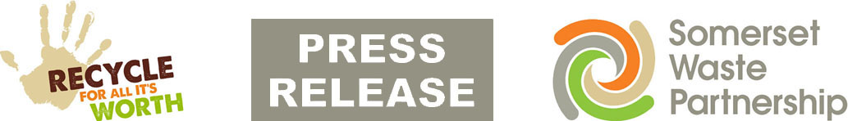

For Immediate Release
24 January 2022

Recycle More: Look out - leaflets landing

An introduction to a new era in recycling is landing on doormats across Sedgemoor and West Somerset this week.

Residents are urged to look out for the striking blue and green “Get Ready for Recycle More” leaflet and log on for a Recycle More Q&A Day this Wednesday to pose queries about the new service.

Recycle More launches to more than 70,000 homes across the area from the end of February, collecting more recycling from the kerb each week and moving rubbish collections to once every three weeks.

The leaflet introduces the basic what, when and why of the service which is already delivering hundreds of tones of extra recycling each week in Mendip, South Somerset and Taunton Deane.

Recycle More adds the following items to weekly recycling collections:
- Plastic pots, tubs and trays
- Food and drink cartons
- Small batteries
- Small electrical items

Every home will have a new recycling container – a "Bright Blue Bag" - delivered before the new service starts.

Extra weekly recycling leaves far less rubbish for the bin. So, rubbish will be collected every three weeks instead of every two. Garden and clinical waste collections will not change with Recycle More.

You can find lots more information about Recycle More online at somersetwaste.gov.uk/recycle-more Extra guidance and support can be requested using an form on this page, or by calling your district council.

And SWP is on hand to field you questions on Facebook, with the next dedicated Recycle More Q&A Day on Wednesday, 26 January, which runs from 7am to 7pm.

Just visit the @somersetwaste page and post questions as comments once the session has started.

Two further sessions are scheduled for Friday 18 February and Wednesday 16 March so save the dates.

Most people in Somerset are recycling and Recycle More makes recycling easier, protecting the environment and helping tackle climate change.

The best way to prepare for the change is to make sure you are making full use of weekly recycling collections and order more containers if you need them.

Everyone can have a green and a black recycling box, plus a food waste bin – more than one if you regularly need more space.

All are FREE and can be ordered quickly and easily online using the My Waste Service menu on the SWP homepage. Whether your boxes are broken, missing or you have never had the full set, order them now.

If your home is a new build, please contact your district council to make sure you have been added to its property register, then order your containers.

A second leaflet delivered three weeks before launch will provide further important detail about Recycle More, including a ‘What goes where?’ recycling guide and an individual collection day calendar.

For information about how to reduce and reuse your waste, visit www.somersetwaste.gov.uk and follow @somersetwaste on Twitter and Facebook.

Where it can, it will also improve recycling for homes with shared or communal collections, for example blocks of flats and homes of multiple occupancy.

These improvements will be brought in later in the year at a date to be confirmed and what is possible will depend on space and access.

[END]

Notes to editors

- Recycle More was introduced in Mendip in October 2020, South Somerset at the end of June this year, and Taunton Deane at the start of November 2021.
- A customer survey in Mendip found that after six months, 84% of respondents said they preferred the new service over the old.

Somerset Waste Partnership manages waste services for all councils in Somerset.

Media contacts:
Nick Cater, Senior Communications Officer Nick Cater,
Nicholas.Cater@somersetwaste.gov.uk

Mark Ford, Head of Communications and Engagement, 07977412198 mford@somersetwaste.gov.uk

